**Lab Exercise 10– Creating an AWS RDS Instance in Terraform**

Objective:Learn how to use Terraform to create an AWS RDS instance.

Prerequisites:

• Terraform installed on your machine.

• AWS CLI configured with the necessary credentials.

Steps:

1. Create a Terraform Directory: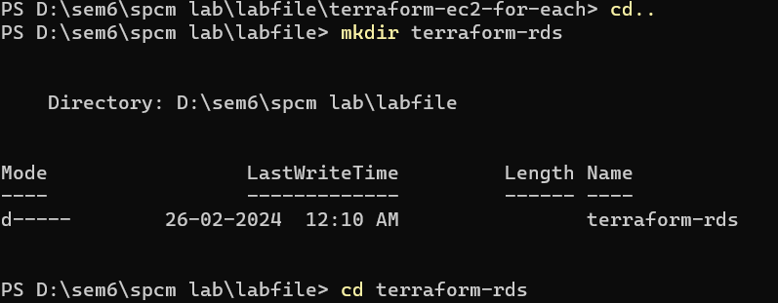
2. Create Terraform Configuration Files:

Create a file named main.tf

# main.tf

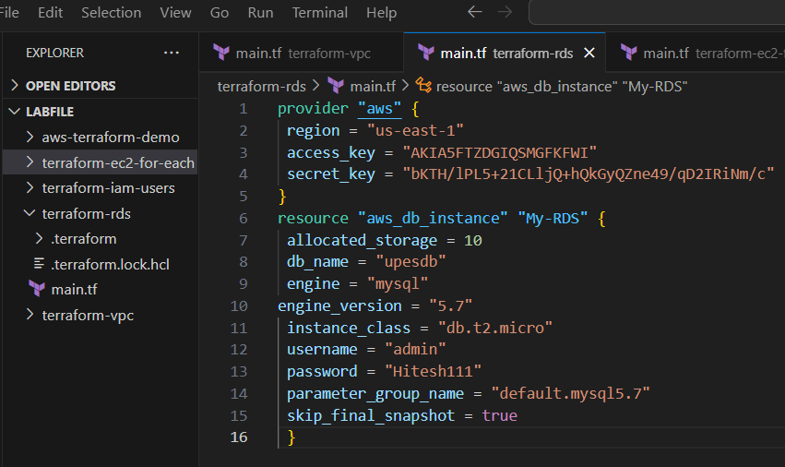

1. Initialize and Apply: Run the following Terraform commands to initialize and apply the configuration:

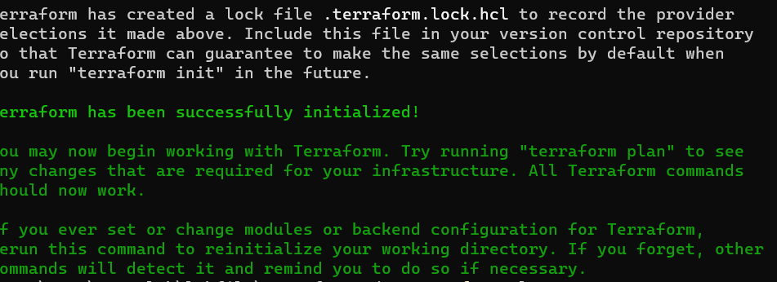

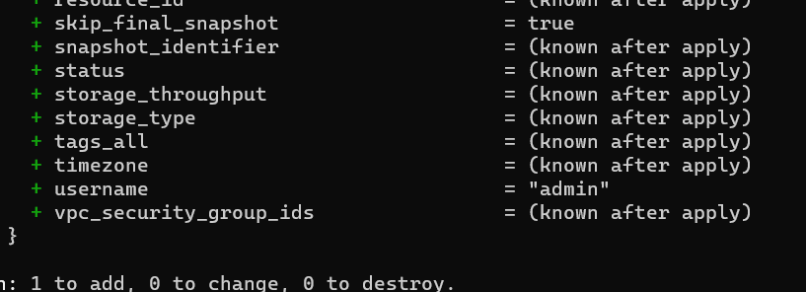

1. . Clean Up: After testing, you can clean up the RDS instance:

